**Question 1**

Q1. find the eligibility of admission for a professional course based on the following criteria: Eligibility Criteria : Marks in Maths >=65 and Marks in Phy >=55 and Marks in Chem>=50 and Total in all three subject >=190 or Total in Maths and Physics >=140 write a program with help a class and use method 'eligibility' which should check all the Eligibility Criteria. use another method to 'setMarks' takes marks as parameters and marks are entered through keyboard.

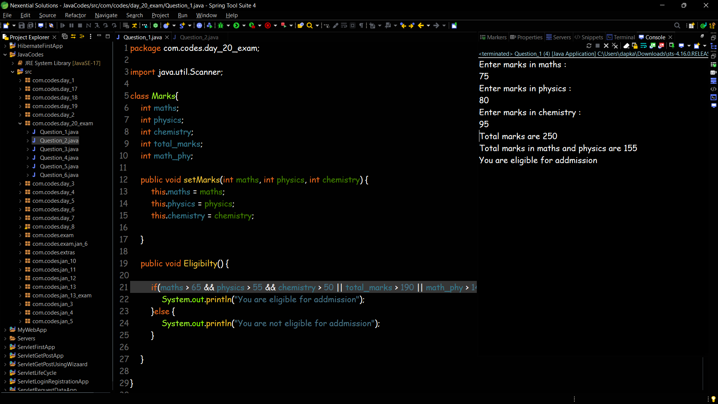

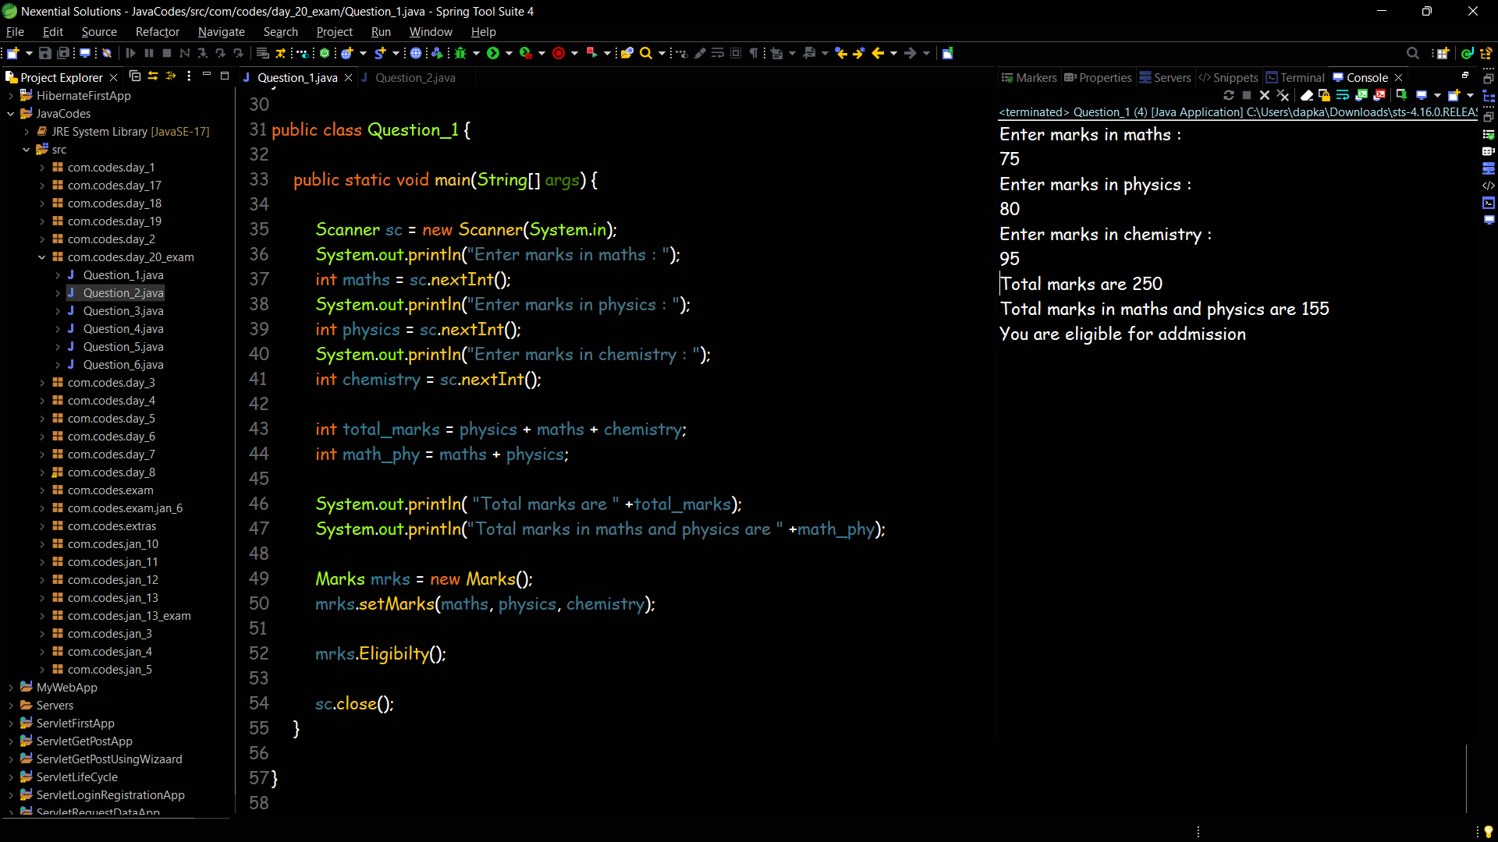

**Question 2**

Create a class called Invoice that a hardware store might use to represent an invoice for an item sold at the store. An Invoice should include four pieces of information as instance variables‐

part number(type String), part description(type String), quantity of the item being purchased (type int) and price per item (double). Your class should have a method that initializes the four instance variables.

Provide a method named getInvoice Amount that calculates the invoice amount (i.e., multiplies the quantity by the price per item), then returns the amount as a double value.

If the quantity is not positive, it should be set to 0.

If the price per item is not positive, it should be set to 0.0.

Write a test application named InvoiceTest that demonstrates class Invoice’s capabilities

get all the values through keyboard.

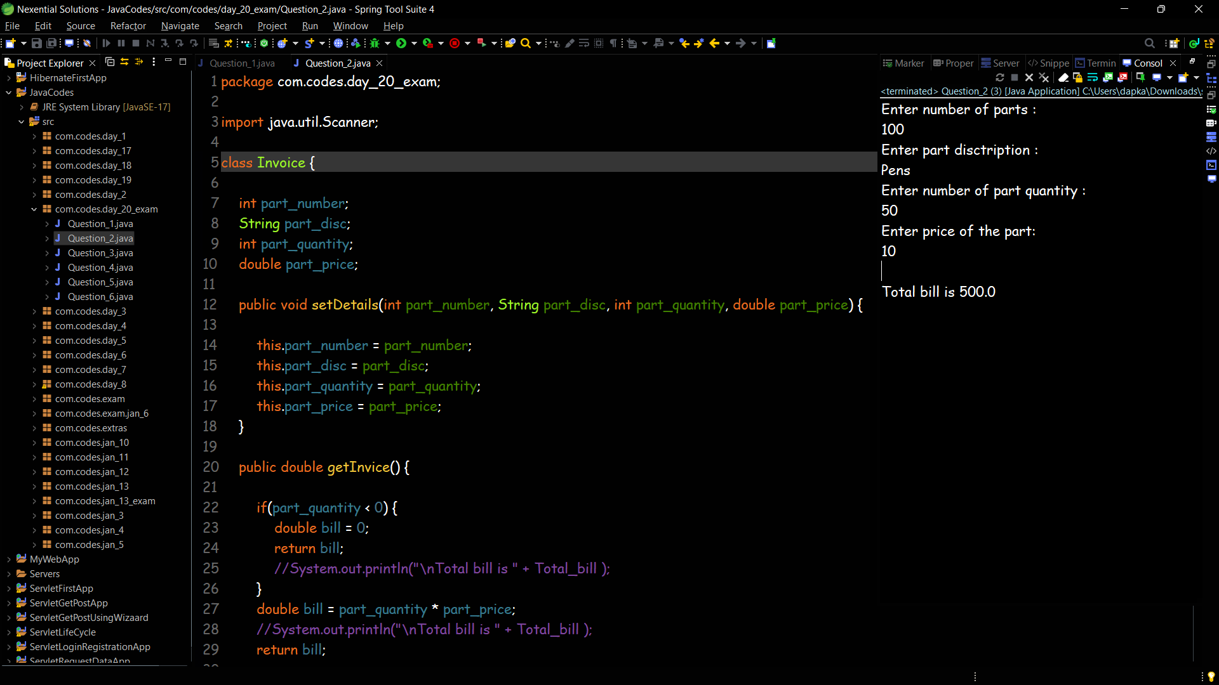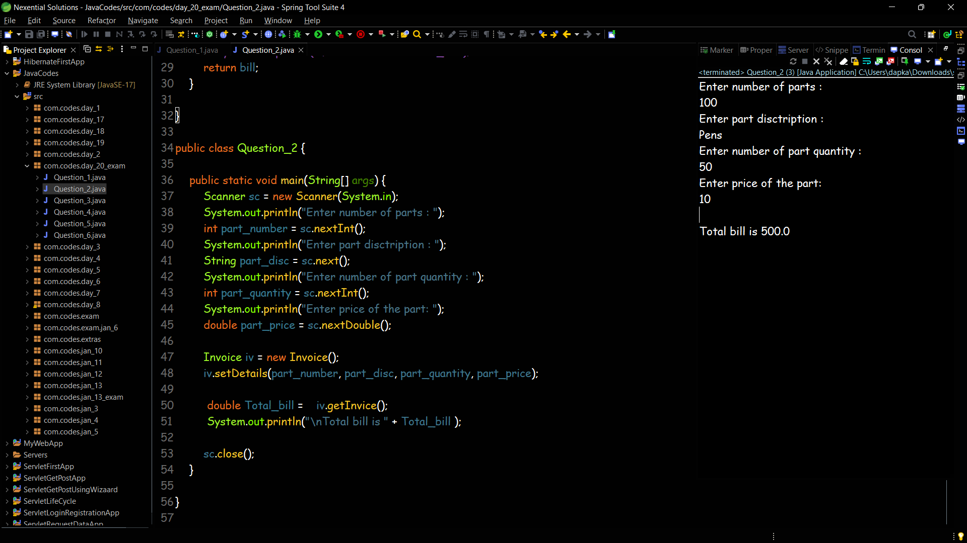

**Question 3**

Q3. Write a Java application that allows the user to enter up to 20 integer grades into an array. Stop the loop by typing in ‐1. Your main method should call an Average method that returns the average of the grades.

Use the DecimalFormat as return type of the method class to format the average to 2 decimal places.

Hint:

Ø double d = 2.456534; System.out.printf("Double upto 2 decimal places: %.2f", d); Ø Pass an Array to a Function : Function call : function_name(array_name); Function definition : returnType functionName(datatype[] arrayName)

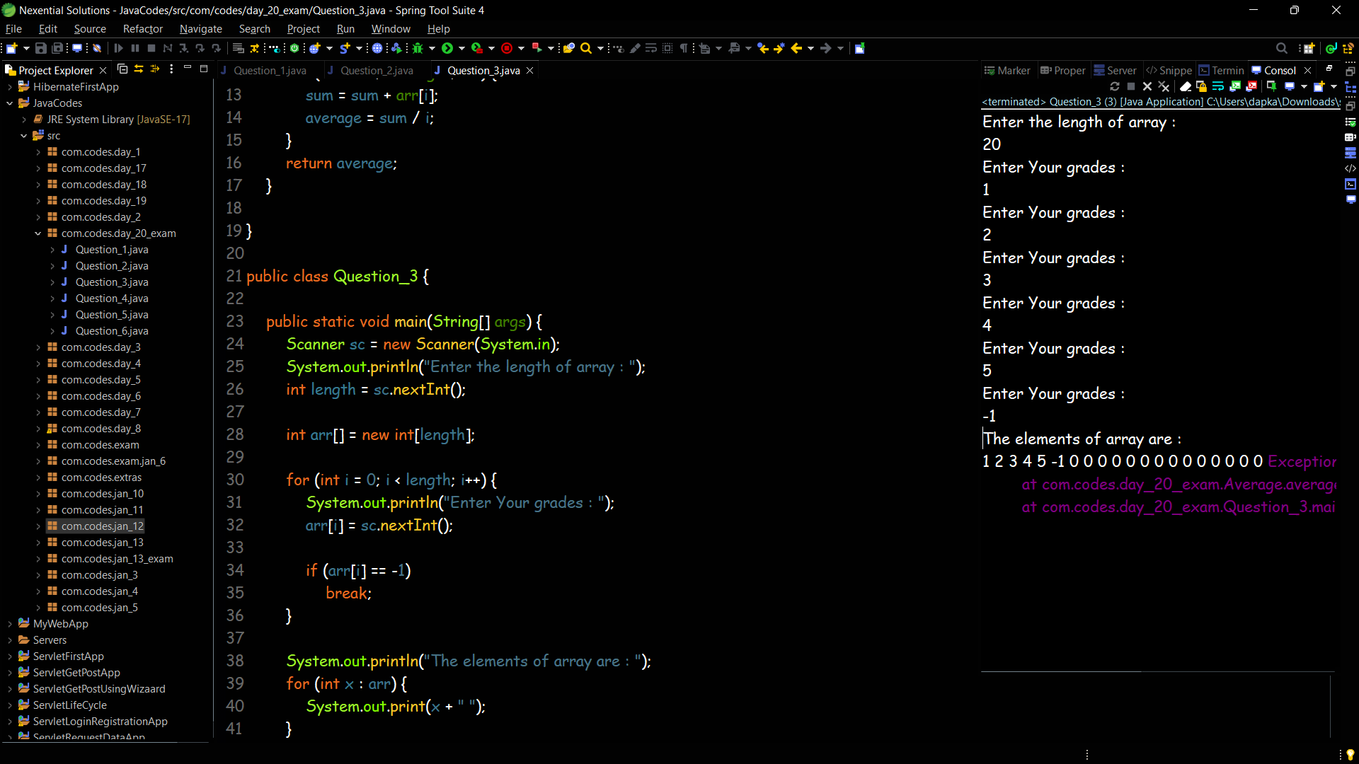

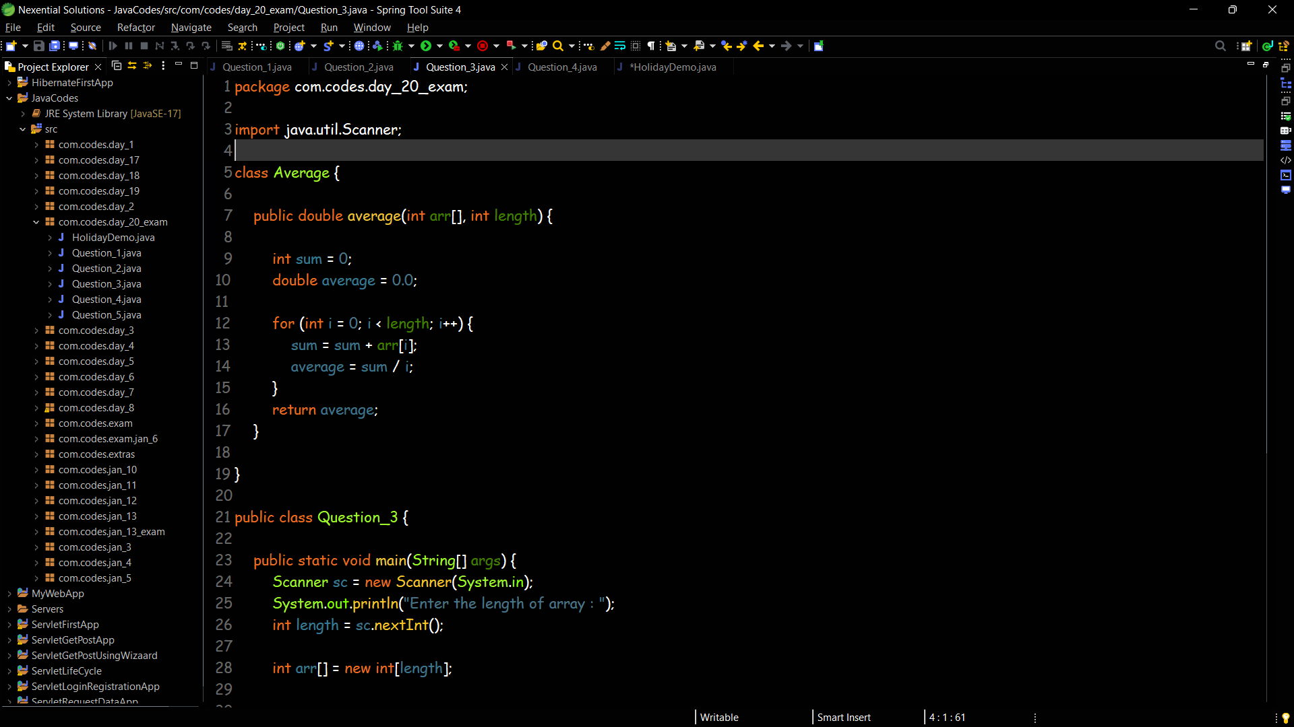

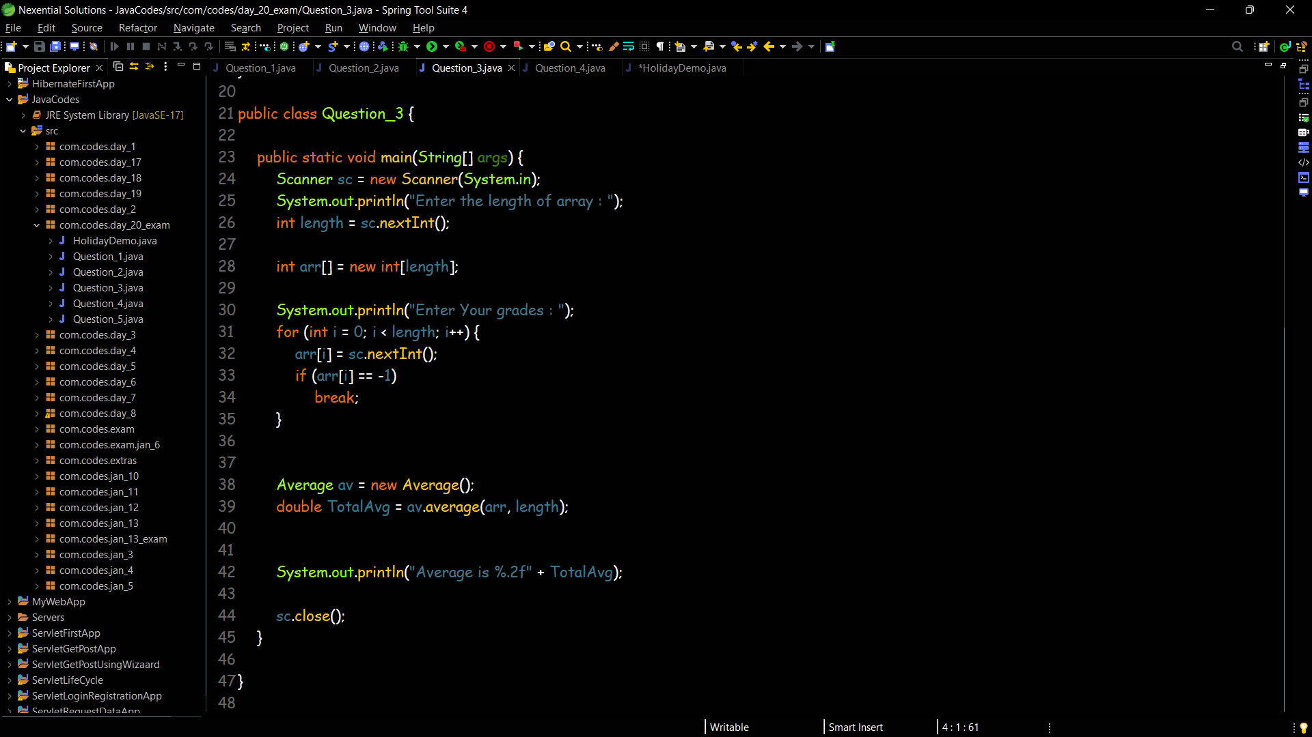

**Question 4**

Write a Java program that reads a string from the keyboard, and outputs the string twice in a row, first all uppercase and next all lowercase. If, for instance, the string “Hello" is given, the output will be “HELLOhello

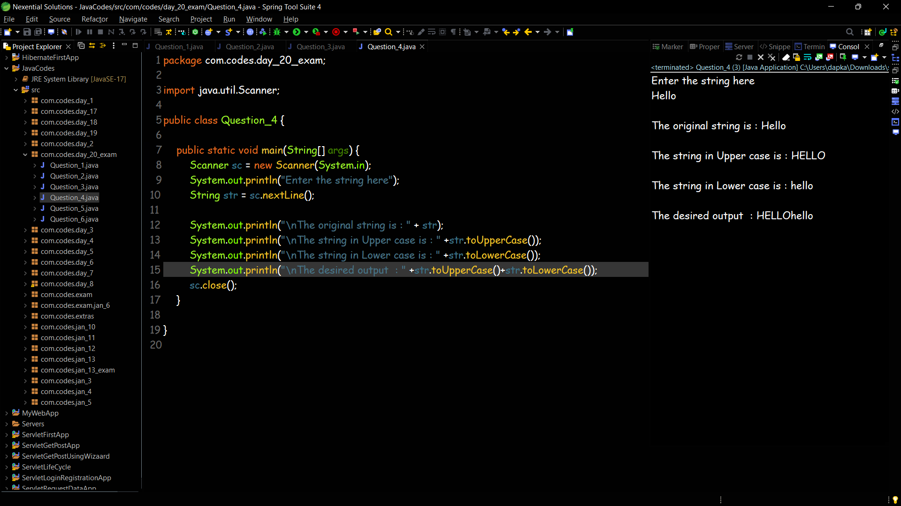

**Question 5**

The Java class called Holiday is started below. An object of class Holiday represents a holiday during the year. This class has three instance variables: ● name, which is a String representing the name of the holiday ● day, which is an int representing the day of the month of the holiday ● month, which is a String representing the month the holiday is in

public class Holiday {

private String name;

private int day;

private String month; // your code goes here }

a) Write a constructor for the class Holiday, which takes a String representing the name, an int representing the day, and a String representing the month as its arguments, and sets the class variables to these values.

b) Write a method in SameMonth, which compares two instances of the class Holiday, and returns the Boolean value true if they have the same month, and false if they do not.

c) Write a method avgDate which takes an array of base type Holiday as its argument, and returns a doubl

